2.

b.

c. 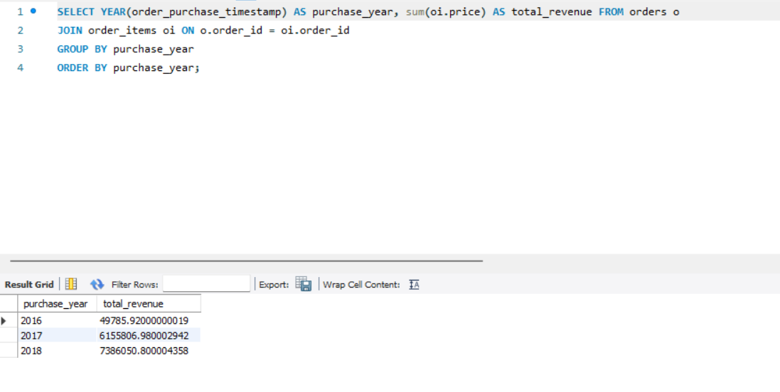

d.

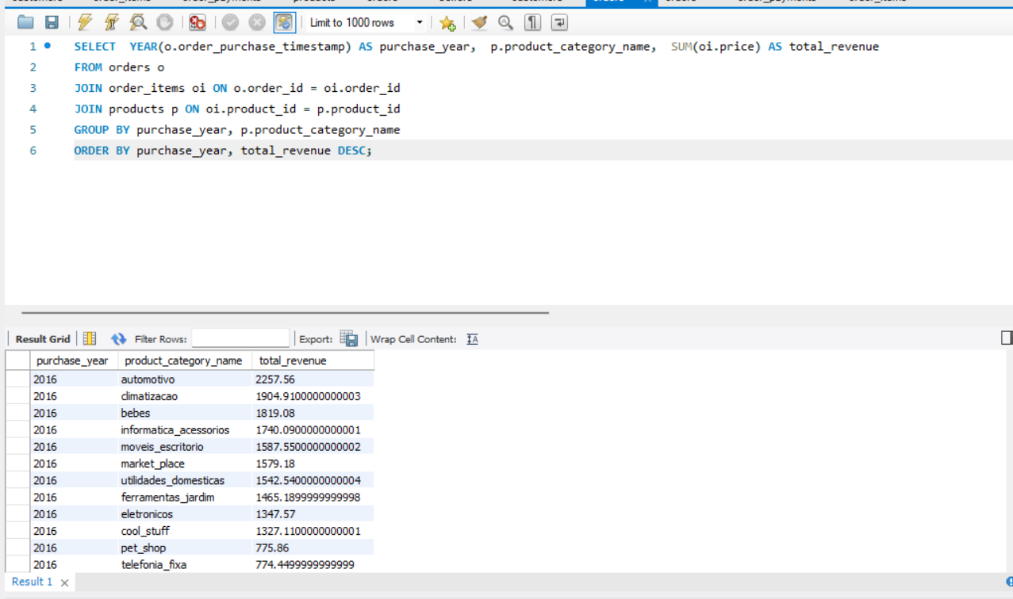

2e

3.

a.

b.

Nhập thử mã khách hàng không có trong data:

4. Tạo một dữ liệu chứa

